Project Design Phase-II
Technology Stack (Architecture & Stack)

Date | 08 July 2026
Team ID | SWTID-2026-1342
Project Name | Nutrition Assistant
Maximum Marks | 4 Marks

Technical Architecture:
Example: Personalized Nutrition Planning System using MERN Stack

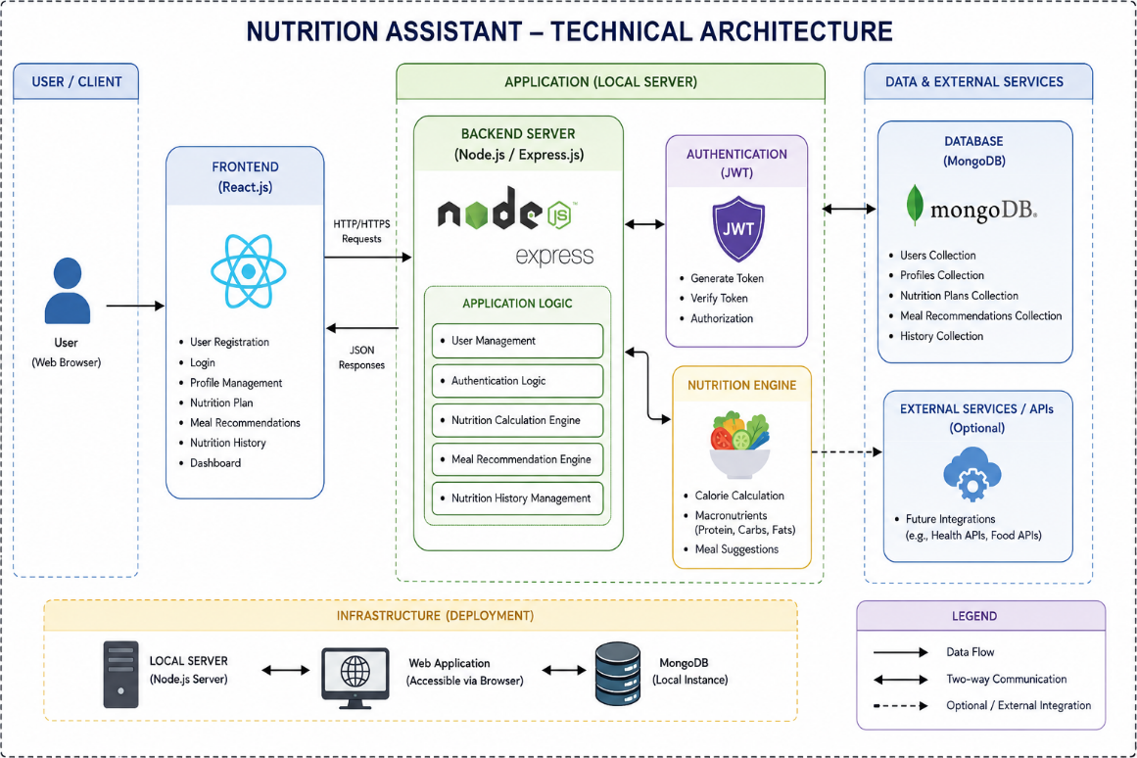
Guidelines:
- User registration, login, nutrition plan generation, meal recommendations, and nutrition history modules.
- React frontend, Express.js backend, and MongoDB database architecture.
- Local server infrastructure with backend and database communication.
- JWT authentication for secure user access and authorization.
- User profile data and nutrition plan storage in MongoDB.
- HTTP/HTTPS communication between frontend and backend.
- Axios for API requests and JSON data exchange.
- Nutrition calculation logic for calories, protein, carbohydrates, fats, and meal suggestions.

Table-1 : Components & Technologies:
S.No | Component | Description | Technology
 | User Interface | Web interface for registration, login, and nutrition plan generation | React.js, HTML, CSS, Tailwind CSS
 | Application Logic-1 | User registration, login, and authentication | Node.js, Express.js
 | Application Logic-2 | Nutrition calculation and meal recommendation logic | JavaScript (Node.js)
 | Application Logic-3 | JWT authentication and authorization | JWT, bcryptjs
 | Database | Stores user details and nutrition plans | MongoDB, Mongoose
 | Cloud Database | Not Applicable (Local MongoDB) | _
 | File Storage | Stores application files locally | Local File System
 | External API-1 | Not Used | _
 | External API-2 | Not Used | _
 | Machine Learning Model | Not Used | _
 | Infrastructure (Server / Cloud) | Local deployment using Node.js server | Local Server

Table-2: Application Characteristics:
S.No | Characteristics | Description | Technology
 | Open-Source Frameworks | Frontend and backend built using open-source technologies. | React.js, Node.js, Express.js, MongoDB
 | Security Implementations | Secure authentication and password encryption | JWT, bcryptjs
 | Scalable Architecture | Three-tier architecture supporting future enhancements | MERN Stack
 | Availability | Accessible through a local web server | Node.js Local Server
 | Performance | Fast API responses and efficient database queries | Express.js, MongoDB

